# How to configure SSH on cisco devices

# How to configure telnet on Cisco Router?

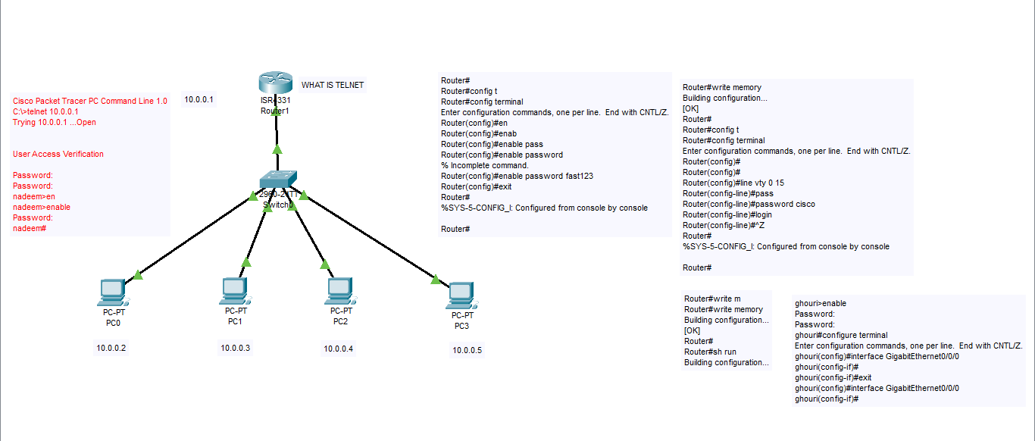

# How to configure telnet on cisco switch?

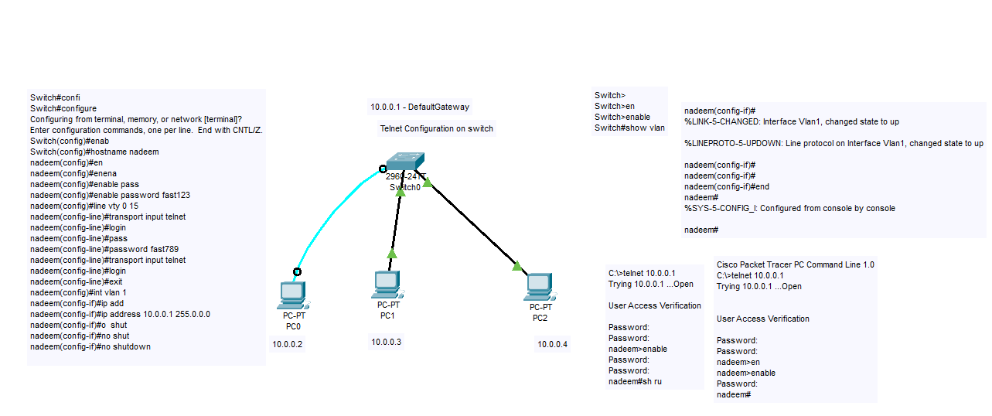

# DHCP configuration on cisco packet tracer

